|  |
| --- |
|  |
| User Manual |
|  |
| Ubiquitous Personalized Health Record System |

**BIOCORE LAB UTEM**

December 10, 2015

Authored by: Amalina

User Manual

Ubiquitous Personalized Health Record System

Table of Contents

Home 3

Product (CSS) 4

Save Patient 7

Product (M-PHR) 11

Product (E-PHR) 13

Table of Figure

Figure 1 3

Figure 2 4

Figure 3 4

Figure 4 5

Figure 5 5

Figure 6 6

Figure 7 7

Figure 8 8

Figure 9 9

Figure 10 9

Figure 11 10

Figure 12 11

Figure 13 12

Figure 14 12

Figure 15 13

Figure 16 13

# Home

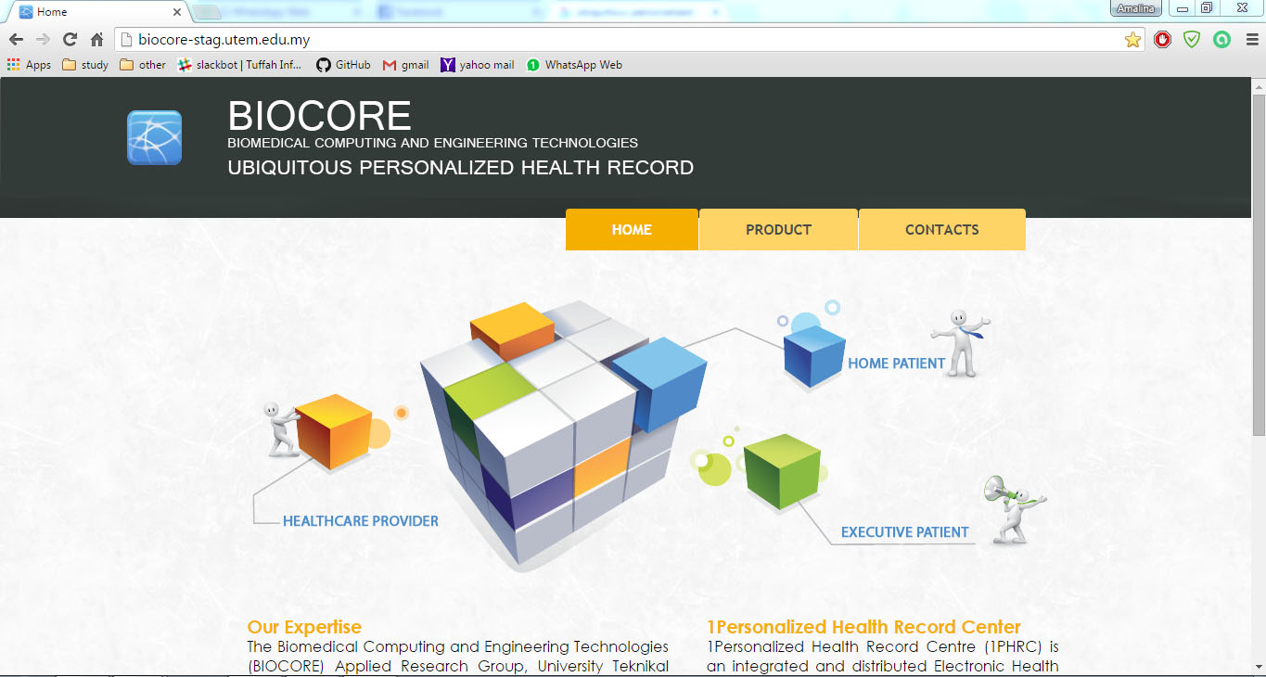

Figure 1

**Step 1:** Go to browser. Enter to webpage by using link <http://biocore-stag.utem.edu.my/>

**Step 2:** Home Page will be displayed.

**Step 3:** Move the cursor to menu panel “PRODUCT” to view the details.

# Product (CSS)

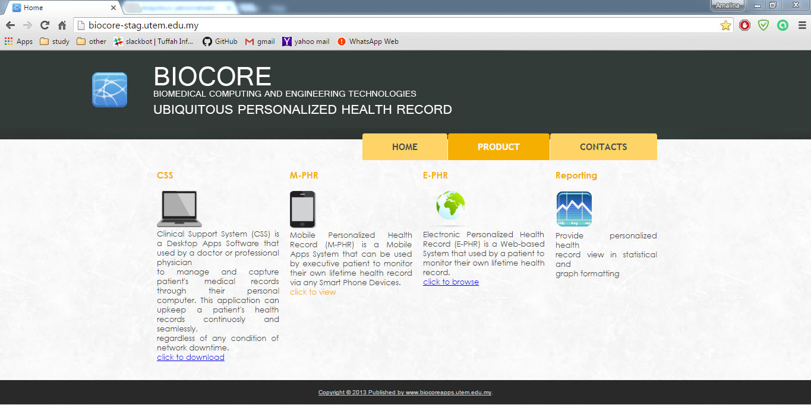

**1**

Figure 2

**Step 1:** To download the Desktop Apps Software Click link below CSS description

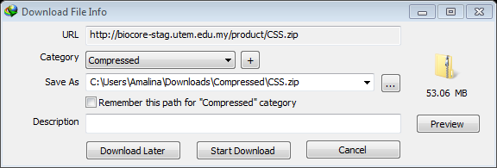

Figure 3

**Step 2:** Download and save path to your drive.

**Step 3:** Extract the file.

**Step 4:** Open file Location. Example: C:\Users\Amalina\Downloads\Compressed\CSS\CSS

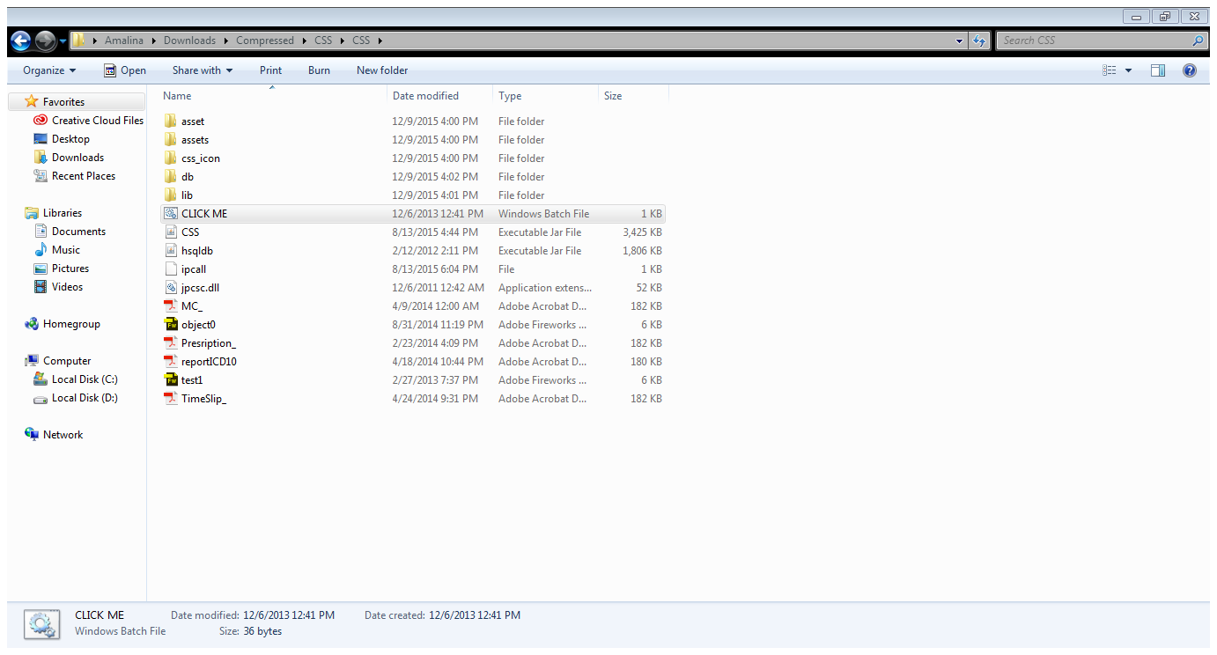

**5**

Figure 4

**Step 5:** Click “CLICK ME” to open apps.

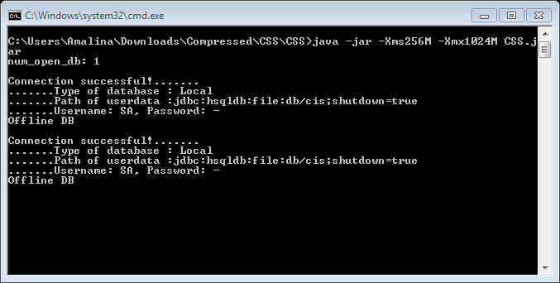

Figure 5

**Step 6:** Apps console will be display for database connection.

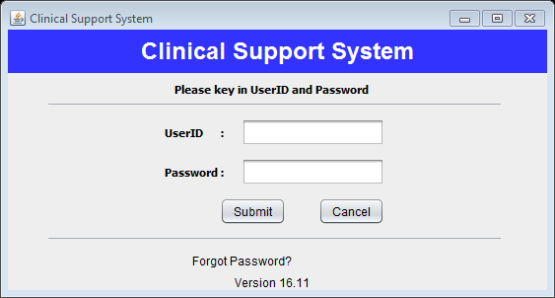

Figure 6

**Step 7:** Login menu will be display. Done! You may continue using this apps by enter the username and password.

**Step 8:** Continue using CSS by referring to CSS user manual.

## Save Patient

**Step 1:** Open Desktop Apps.

**Step 2:** Go to “Patient Consultant” menu.

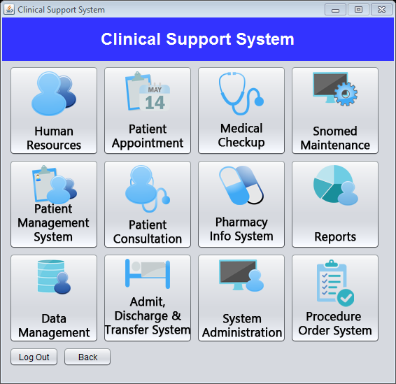

Figure 7

**Step 3:** Click “Select Patient” button.

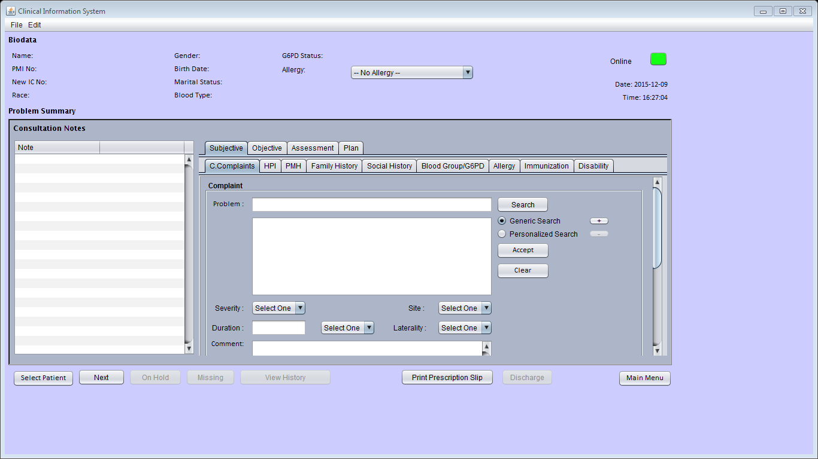

Figure 8

**Step 4:** Select patient registered in system. After that click “OK” button.

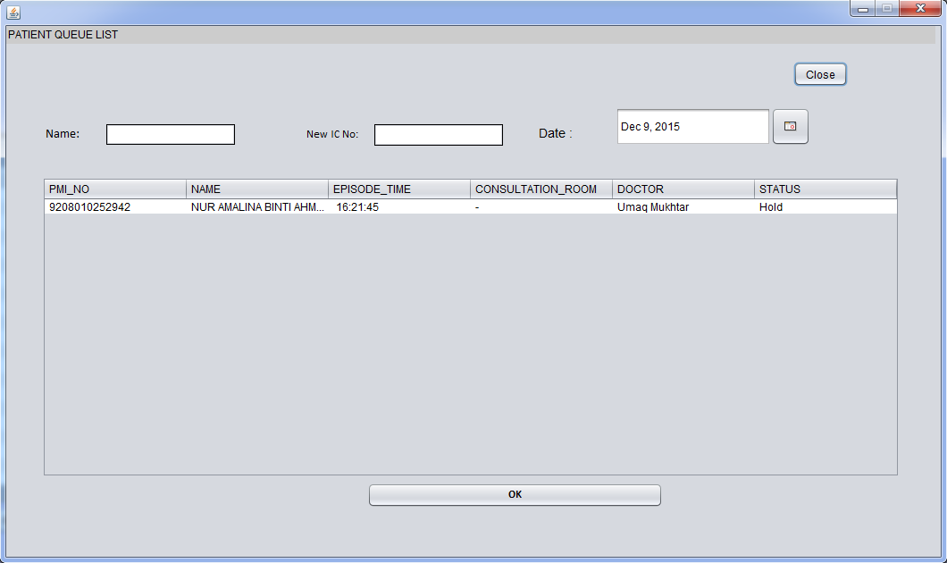

Figure 9

**Step 5:** Click “File” at menu bar to select location to save data. Mark the location needed.

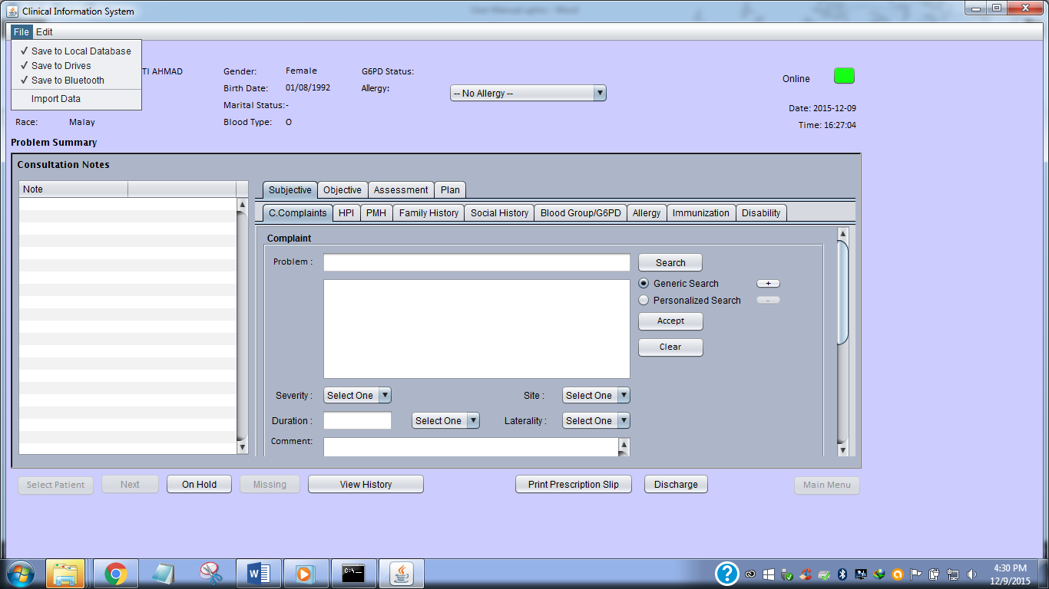

Figure 10

**Step 6:** Fill the patient consultant.

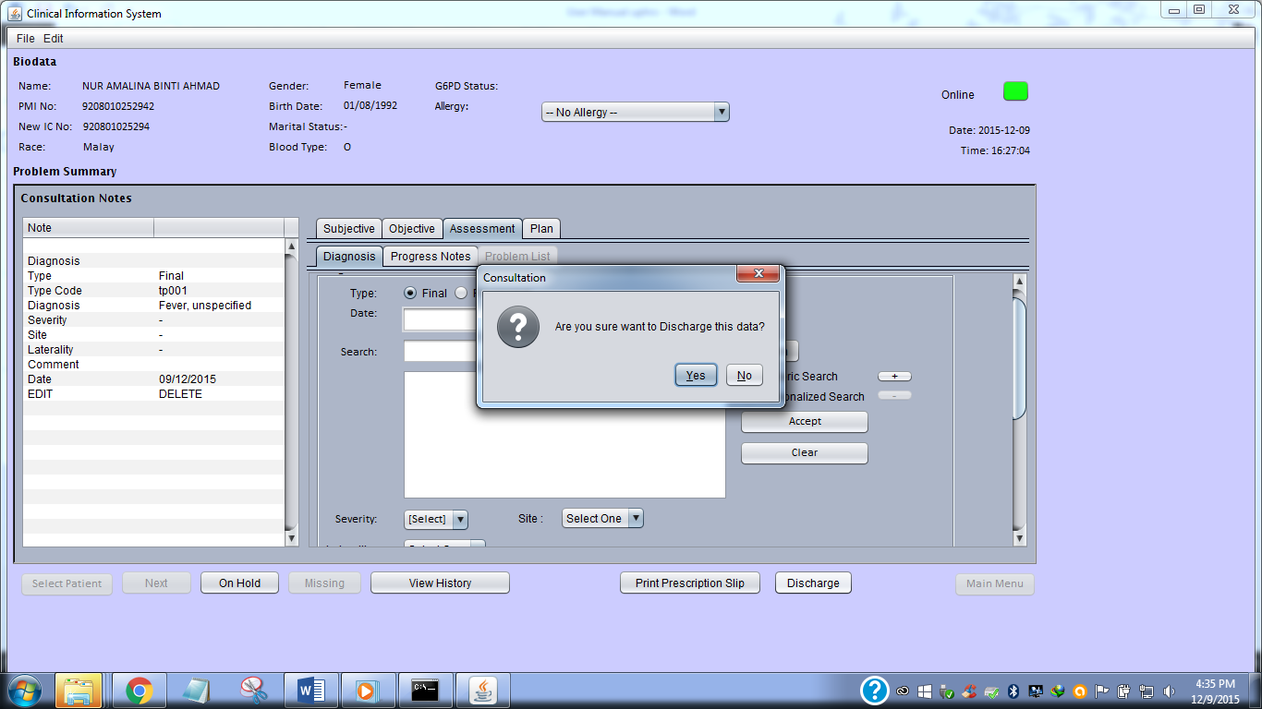

Figure 11

**Step 7:** After finish the consultation, Click “Discharge” button and “OK” for confirmation.

# Product (M-PHR)

**Step 1:** To download the M-PHR for mobile application go to Google Play <https://play.google.com/store/apps/details?id=com.css.M_PHRv6&hl=en>

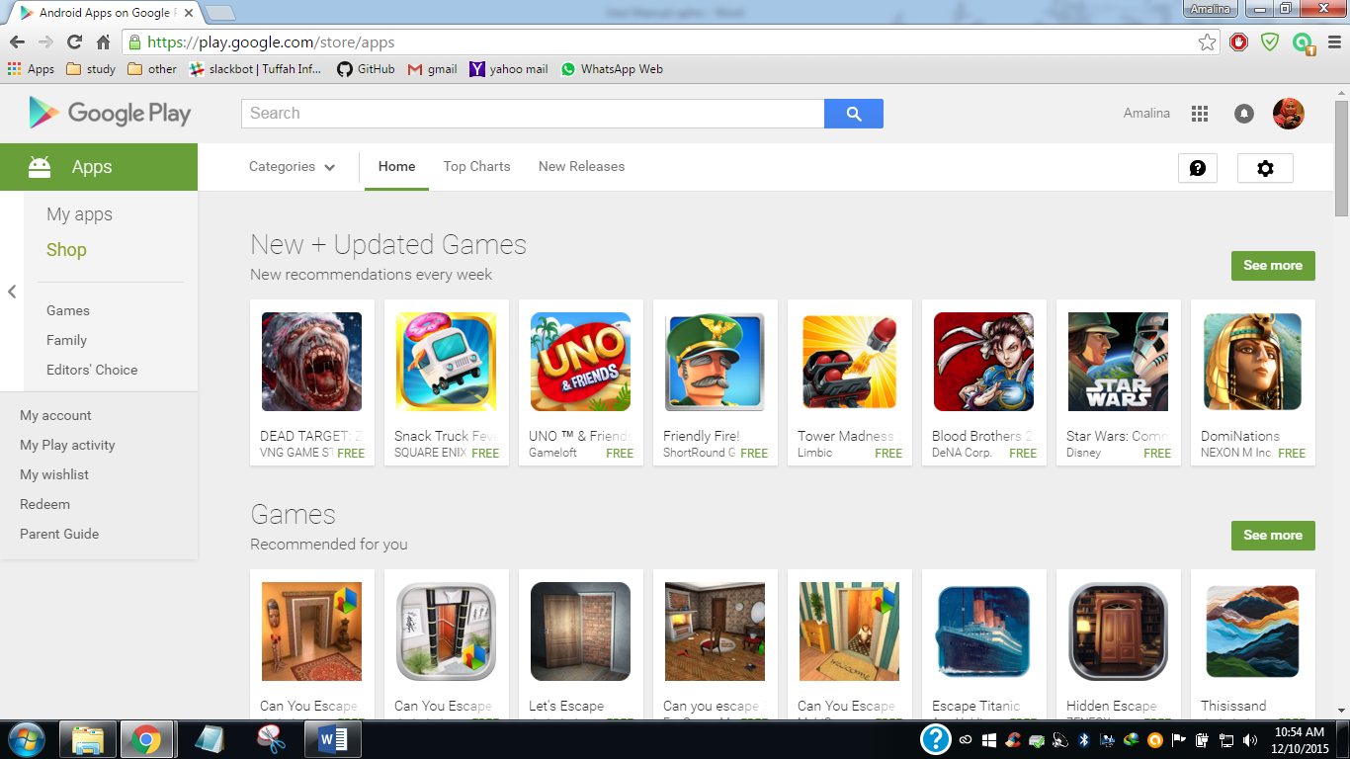

Figure 12

**Step 2:** Browse “M-PHR” at searching box.

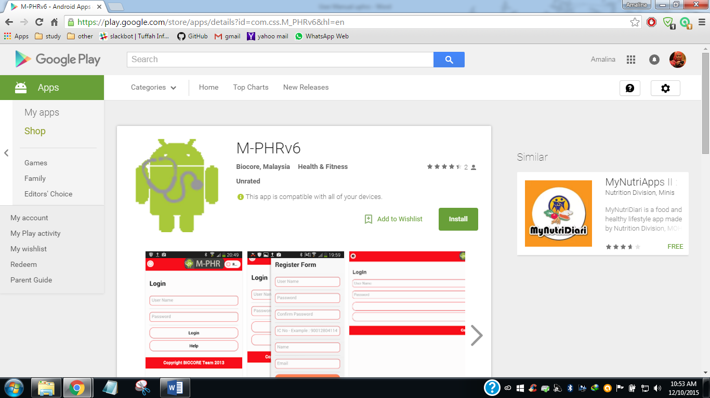

Figure 13

**Step 3:** Click “Install” button to install at your mobile phone.

**Step 4:** Done! Continue using M-PHR by referring to M-PHR user manual.

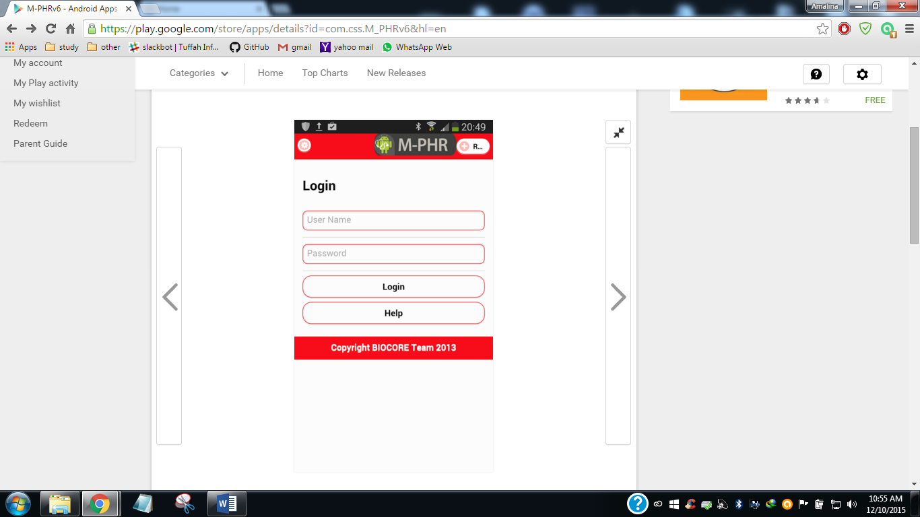

Figure 14

# Product (E-PHR)



**1**

Figure 15

**Step 1:** To browse the E-PHR Click link below E-PHR description

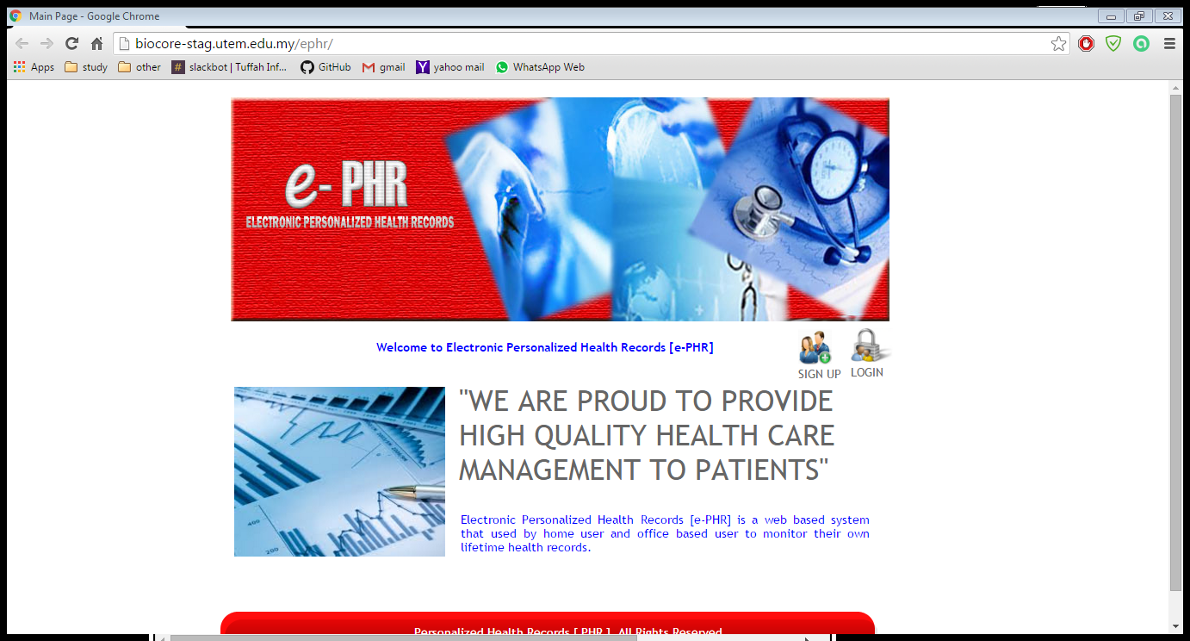

Figure 16

**Step 2:** Home Page E-PHR will be displayed.

**Step 3:** Click link “SIGN UP” to register new user or click “LOGIN” for existing user.

**Step 4:** Continue using E-PHR by referring to E-PHR user manual.